RUNE PROJECT CALL

REQUEST FOR QUOTATION

February 2018

Table of Contents
1. ABOUT “RUNE” PROJECT 4
1.1. WHAT IS “RUNE” 4
1.2. GENERAL INFORMATION 5
2. PURPOSE AND ROLE OF “RUNE” PROCUREMENT POLICY AND PROCEDURES 8
2.1. PURPOSE OF PROCUREMENT POLICY AND PROCEDURES 8
2.2. OBJECTIVE 8
2.3. SCOPE 8
2.4. POLICY STATEMENT 8
2.5. RELATED RULES 8
3. PROCUREMENT PHASES AND DOCUMENTS 9
3.1. GENERAL DESCRIPTION OF PROCUREMENT PHASES AND PROCEDURES 9
3.2. ORIENTATIVE TENDER VALUES 10
3.3. PROCUREMENT PROCEDURE 1: DESIGN PHASE (PP1) FOR PASSIVE INFRASTRUCTURE 11
3.3.1. INDICATIVE SCOPE OF WORK 11
3.3.2. SUBMISSION DATA 12
3.3.3. LIST OF RETURNABLE DOCUMENTS 13
3.3.4. RETURNABLE SCHEDULES 13
3.4. PROCUREMENT PROCEDURE 2: SUPPLY OF MATERIALS (PP2) 14
3.4.1. INDICATIVE SCOPE OF WORK 14
3.4.2. PROSPECTED QUANTITIES 14
3.4.3. Materials 15
3.4.4. SAMPLES 16
3.4.5. SUBMISSION DATA 16
3.4.6. LIST OF RETURNABLE DOCUMENTS 16
3.4.5. RETURNABLE SCHEDULES 16
3.5. PROCUREMENT PROCEDURE 3: SUPPLY OF ACTIVE NETWORK LAYER (PP3) 17
3.5.1. INDICATIVE SCOPE OF WORK 17
3.5.2. TECHNICAL SOLUTION FOR THE ACCESS NETWORK 18
3.5.3. NETWORK MANAGEMENT/PROVISIONING 19
3.5.6. EQUIPMENT AT THE PASSIVE DISTRIBUTION AGGREGATION NODE (PAN) 20
3.5.7. USER SIDE ACTIVE EQUIPMENT 20
3.6. RUNE NETWORK SCHEMES 22
3.6.1. GENERAL SCHEME 22
3.6.2. ACCESS NETWORK SCHEME 23
3.7. MATERIALS 24
3.7.1. Cables 24
3.7.2. Pipes 24
3.7.3. Manholes/manhole closures 24
3.7.4. Cable supports for aerial cable deployment 24
3.7.5. Cabinets 24

ABOUT “RUNE” PROJECT

WHAT IS “RUNE”

RUNE project aims at deploying a Greenfield cross-border wholesale broadband network targeting underserved areas in Slovenia and Croatia. The infrastructure will provide several residents and small-businesses with a gigabit Next Generation Access (NGA) broadband infrastructure. The project includes a Fiber to the Home (FTTH) component and will offer wholesale services only, on an active layer open access basis, to other service providers. The infrastructure deployment will leverage, to the maximum possible, the reuse of existing infrastructure and the most efficient technologies and cost reduction measures.

The proposed network will cover a number of villages in Slovenia, and clusters of villages in Primorsko-Goranska and Istarska counties (Croatia), targeting a rural area of 344,900 potential network points, all of which are currently not covered by a fibre NGA network.

Area | Area (km²) | Number of villages | Households on white areas | Length of county and local roads
Slovenia | 8.000 | 3.585 | 235.000 | 3.585.000
Croatia (PGŽ and Istarska counties) | 5.320 | 1.127 | 109.000 | 1.127.000
TOTAL Rune | 13.320 | 4.712 | 344.900 | 4.712.000

Final numbers might change, last official list is published on www.ruralnetwork.eu.

For the purpose of this document open access network (OAN) is defined as network where the access to the active network services is granted to any provider under the same fair and transparent conditions.

RUNE will act as a wholesale only active layer infrastructure operator, offering high capacity bitstream (VULA type) service to service providers.

- Layer 2 transparent networks, where content providers provide the connectivity and services connected with their date streams. The line terminal at the end user’s premises is provided by RUNE. The demarcation point (the User-To-Network Interface, UNI) is one or more 1GE and/or 10GE ethernet interface at the user premises;
- Layer 3 networks, where besides the services described in the previous point RUNE also ensures the connectivity layer, providing DHCP, security, traffic policing and other possible basic network services. The line terminal at the end user’s premises is provided by RUNE. The demarcation point (the User-To-Network Interface, UNI) is one or more 1GE and/or 10GE ethernet interface at the user premises.

All services will be offered at national level access (redundant), and with wire-speed capacities (zero oversubscription) both on aggregation and access level.

GENERAL INFORMATION

The word “RUNE” in this document refers to all legal entities acting with the goal to reach “RUNE” project targets by using “RUNE” project funds. At the moment of issuing this RFQ, it refers to RUNE-SI d.o.o., a Slovenian company, and RUNE-ADRIA d.o.o., a Croatian company.

The subjects of this Call for quotation are:
- Design of the passive layer of the future network
- Construction of the passive layer of the future network
- Supply and integration of active network layer systems.
The goal of the RFQ is to close the contractual phase until 31.3.2018 and start execution of works.

This Call contains also a separate section, RFI for the materials, needed for the passive network. RUNE will contract type, quality, prices and other economic conditions for the materials. This will be bought by the chosen contractors for the »Design and construction of the passive layer« directly from the chosen supplier, and sold to RUNE once built-in. RUNE will not buy the materials directly, so the procedure for materials will end by signing supply agreements with chosen suppliers, but not with the order from RUNE’s side.

A more detailed description of the foreseen procurement processes is provided in Chapter 3.

This RFQ is aimed to the widest possible stakeholder audience. In this phase, we would like to have as many contributions as possible, at list from the following groups:
- Service providers, willing to offer their services, to express their expectations in terms of technical requirements and services that should be offered over the RUNE's network;
- Infrastructure providers, willing to sell/rent their excess/free existent infrastructure, to be re-used for the new infrastructure deployment;
- Suppliers of materials, needed to build the network (a parallel RFI will be issued for the materials);
- Suppliers/integrators of active layer solutions, that can be used to offer infrastructural network services;
- Building companies/groups of building companies/engineering companies, willing to undertake the planning and the building of the passive network infrastructure;
- Any other subject/stakeholder that might have interest in being involved in the procedure.

Bidders are required to submit their first response until the 10th of March 2018, stating to which procedure/part of procedure exactly they want to participate (use naming as defined in “GENERAL DESCRIPTION OF PROCUREMENT PHASES AND PROCEDURES”.
Upon this first response, the bidders will be assigned with individual bidder’s code (BIC) for each procedure they request to participate to. From that moment on, the BIC code should be cited in the title of any communication, related to the specific bidder/procedure.

One or more meetings (a competitive dialogue), where bidders will be allowed to explain their proposal ideas will be organized from the first response until the date of final quotation. Based on the result of the competitive dialogue meetings, final requirements of the tender will be precisely defined. All the meetings will be held in Rune-SI premises ( address: Partizanska cesta 109, 6210 Sežana, Slovenija ), and minutes of meeting will be agreed and shared between the participants.
Bidder validation documents, similar to those requested in public procurement procedures, and bidder’s references will be discussed in the first step.

Bidders will be required to submit the final quotation with the necessary supporting documents not later than 31.3.2018!

All the communication must be sent via email to goran.zivec@ruralnetwork.eu and sasa.ukic@ruralnetwork.eu . All the communication to the bidders, coming from ruralnetwork.eu domain should be considered official.

The first quotation should contain the documents, requested for each section, as specified further in this document.

All further correspondence with respect to this RFQ should be communicated to:

Name: | Goran Živec
Position: | RUNE-SI d.o.o., CEO
Mobile: | +386 41 342 599
E-mail: | goran.zivec@ruralnetwork.eu

Name: | Saša Ukić
Position: | RUNE-ADRIA d.o.o., CEO
Mobile: | +385 98 327 190
E-mail: | sasa.ukic@ruralnetwork.eu

Any requests for clarification should be sent in a table, as attached (question_table.xlsx) to this call, one question per line. All questions sent until 23rd of March will be answered via email before the final date and published together with the answers on the RUNE’s website, to be publicly visible.

Dates might be extended, if necessary.

20th of February 2018

RUNE-SI d.o.o. RUNE-ADRIA d.o.o.
Goran Živec Saša Ukić

PURPOSE AND ROLE OF “RUNE” PROCUREMENT POLICY AND PROCEDURES

PURPOSE OF PROCUREMENT POLICY AND PROCEDURES
The purpose of the policy is to ensure in all of “RUNE” procurement activities:
- consistency across the project;
- compliance with legislation and key directions given by the international procurement standard ISO 10845;
- to ensure openness and transparency of decision-making;
- to define the best possible market conditions for all the supplies and services that will be required in the project

OBJECTIVE
The aim of this policy is to ensure that “RUNE” procurement policies are efficient, clearly defined, deliver value for money and do so in accordance with best practices given by international procurement standard ISO 10845

SCOPE
The policy covers all activities related to purchasing of goods and services by all “RUNE” Staff across all business units.

POLICY STATEMENT
“RUNE” is committed to ensuring its purchasing practices are sustainable, efficient and deliver value for money, whilst encouraging a competitive environment amongst its suppliers and ensuring a safe working environment for its staff and contractors.
“RUNE” purchasing practices will be based on the following principles:
- Value for Money: Obtain the best quality and value for the price and that the qualitative system requirements meets “RUNE” criteria regarding the policy, performance, risk and costs constraints.
- Open and Fair Competition: Treat all current and prospective suppliers and vendors fairly in an open and transparent manner without any bias or the perception of bias.
- Accountability: Provide clear lines of responsibility and requirements for compliance with best practice guidelines.
- Risk Management: Include management strategies to identify, minimize and control risk associated with different stages of the procurement process and to enhance council’s capability to prevent, withstand and recover from interruption to the supply of goods, services and works.
- Probity and Transparency: Demonstrate the highest levels of integrity consistent with the “RUNE” project interests. Ensuring fairness and impartiality towards suppliers; consistency and transparency in the competitive process; and providing security and confidentiality for the commercial interests of existing and potential suppliers.

RELATED RULES
International procurement standard ISO 10845

PROCUREMENT PHASES AND DOCUMENTS

GENERAL DESCRIPTION OF PROCUREMENT PHASES AND PROCEDURES
The procurement will be held separately for each of the 3 procurement phases as shown in the picture below.

Picture: Overview of project procurement procedures

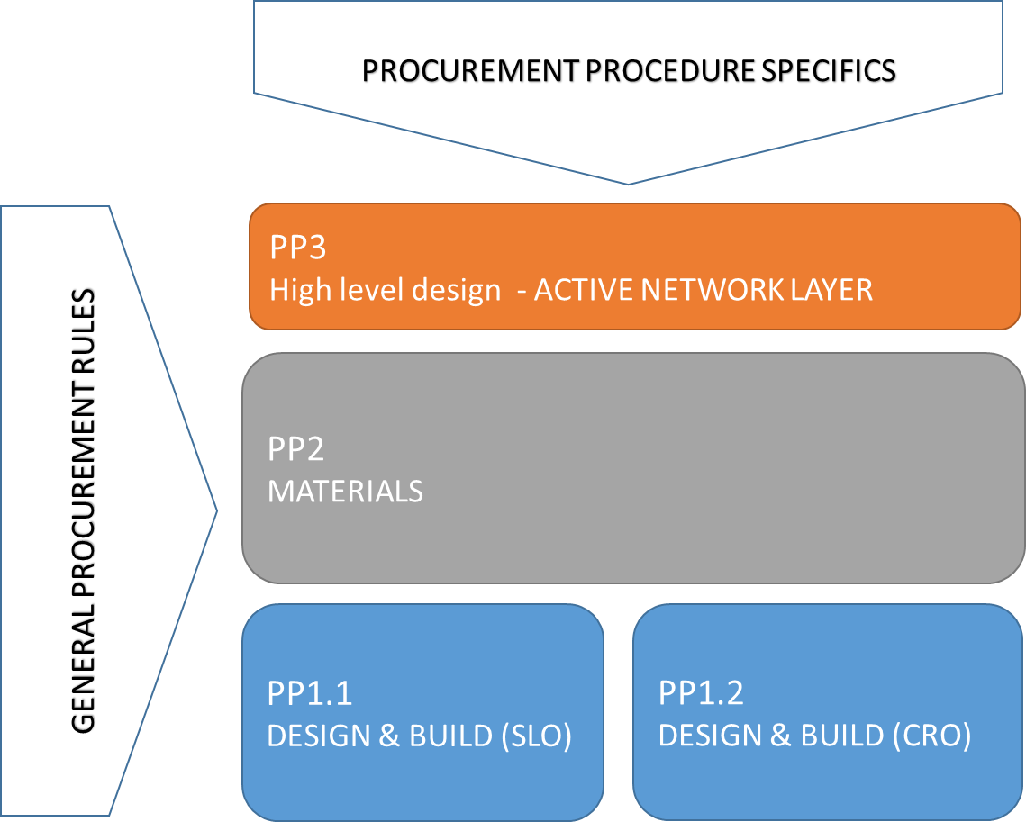

PP1.1 and PP1.2 procedures are aimed at the design and construction of the passive layer of the future network. Both contain designing and building of the infrastructure and include all permission gathering, in a way to reduce the operative risk deriving from the differences between the plan and the effective situation on the field.

PP1.1 and PP1.2 correspond geographically to Slovenia and Croatia part of the RUNE planned territory. Each of those will be furtherly divided (currently three sub-phases in Slovenia and two sub-phases in Croatia are foreseen) in more phases, to aid smooth execution.

With PP2 RUNE intends to choose the most appropriate materials (only certified materials can be built-in) and contract the project price with the supplier. The materials will be bought from the Contractors of PP1.1 and PP1.2 and sold to the investor once properly built in the project.

An open competitive dialogue procedure will be used to select the best offer in all 3 procurement processes. Final details will be defined during RFQ procedures.
Tenderers will submit tender offers in response to the RFQ. RUNE will evaluate the offers and determine who may enter into competitive negotiations, as per ISO 10845-1.

In the competitive dialogue, RUNE will negotiate with responsive and qualified tenderers, through one or more rounds (two rounds are foreseen), based on their rankings or other number of tender-evaluation points, until remaining bidders are invited to submit final offers.

Bidders will be informed of the competitive negotiation process and notified of the evaluation criteria and associated weightings in the tender data before or within the call for final offer. All evaluation criteria will be defined in the RFQ process, before the call for final offer.

The procedures might not end simultaneously, as the procedure about “Passive network design” will be treated with precedence, to be able to start execution of the project as soon as possible. RUNE aims to close all the procedures in the shortest time.

ORIENTATIVE TENDER VALUES

CAPEX
Administrative costs and cost of project documentation before construction | 4,000,000
Construction permits and authorizations | 1,400,000
Civil works (digging, laying pipes, manholes, etc.) | 135,000,000
Base cost (primary distribution) | 85,000,000
Base cost (secondary distribution) | 50,000,000
Passive infrastructure installation (cabling, splicing, measurements, etc) | 23,000,000
Cost of acquisition and/or setting up locations for network's primary nodes | 250,000
Cost of materials and passive equipment | 37,000,000
Cost of active equipment | 14,000,000
Surveying and recording of the works for public utility cadastre | 3,000,000
TOTAL CAPEX (euros) | 217,650,000

Any request in this RFQ may change or be adapted during the procedure, before the call for final offer.

Up until the signature of final contracts with the awarded bidders, any disclaimer is not binding for the parties involved, and each party involved bears its own costs that arise from and during the procedure.

PROCUREMENT PROCEDURE 1: DESIGN PHASE (PP1) FOR PASSIVE INFRASTRUCTURE

INDICATIVE SCOPE OF WORK
After consulting the potential bidders during the RFI procedure, RUNE decided not to tender the building of the passive layer of the network on a “design and build” basis. This is why this procedure is related to design of the passive infrastructure only, separately for Slovenija and Croatia.
Two separate procedures will follow, one for Slovenian part and one for Croatian part of the passive infrastructure build-out, to reflect differences on the legal obligations and requirements, related to the building phase.
Tables with indicative number of residential (household) network points to be planned (and later built) are published on www.ruralnetwork.eu. Beside those, a consistent number of companies, public bodies and other network points are present in the project area and will have to be built.

The network will be built upon the following restraints/specifications
- The topology must concentrate on as few active points as possible, to contain CAPEX and OPEX. Space is an issue, and so is energy consumption, cooling, uninterrupted power supply and physical security;
- The topology of the active network must be thought in a way that new network parts can be added without the need to redesign the whole concept. In the final stage, the solution must enable multiple rings, connecting each access node with two or more aggregation nodes.

An overall planning constraints will be submitted to every bidder after the BIC code assignment.

Please see also chapter 3.4 for additional info about the overall requirements.

The work of this PP will comprise as follows:
Activity | Description | Remarks
NETWORK PLANNING  /DESIGN | Passive network layer design, obtaining all necessary permissions. | - Network design of the aggregation and primary access network (feeder lines, distribution nodes, distribution network to splice box level)  - Secondary access network design guidelines  - Two tenders divided into geographical units – individual tender for each country.
CONSTRUCTION WORKS | Digging, duct installation, cable blowing, aerial cable installation, installation of distribution cabinets, as-built documentation making, and all other services associated with construction and documentation, geodetic surveying of executed work and inscription of the infrastructure in the public registers | - Building of aggregation and primary access network passive infrastructure.  - Maximum possible use of existing infrastructure, if convenient.  - Two public tenders divided into geographical units – individual tender for each country.  - Tender is based on turnkey model.  - Monthly invoicing on executed works.
ON-SITE ASSEMBLY | Construction of distribution network from distribution node to end customer along with in house network installation (installation and connection of splice boxes, optical cable installation, installation and connection of ODF-s, ONT installation, optical line measurement, as-built documentation, obtaining all necessary permissions, geodetic surveying of executed work and inscription of the infrastructure in the public registers, and all other administrative tasks) | - Secondary access network building.  - In house network installation (at the end customer expense).  - Selected construction companies buy materials from contracted vendors and sell it as installed to RUNE, handling fee in amount of maximum 1,5% from material cost is accepted.  - Monthly invoicing of executed works per connected end user.  - Two public tenders divided into geographical units – individual tender for each.  - Tender is based on turnkey model.

The bidders that will be awarded to design the network (first task of the previous table), will have a contractual obligation to present an offer also for the build-out phase (second and third task of the previous table).

SUBMISSION DATA
Please NOTE, upon this first response, the bidders will be assigned with individual bidder’s code for each procedure they request to participate to. From that moment on, the assigned code should be cited in the title of any communication, related to the specific bidder/procedure.
Participants are invited to submit as much material they feel necessary in this phase. More stringent rules may be set in the following steps.
Format of the questions is defined in the attached “question_table.xslx”.

LIST OF RETURNABLE DOCUMENTS
For this phase, form is not mandatory, to stimulate as many stakeholders as possible to participate. After the initial response, the tenderer will use the bidder/procedure codes in any communication, except in messages addressed to general public and/or all bidders. More stringent rules may be set in the following steps.

RETURNABLE SCHEDULES
For this phase, returnable schedules are not set, to stimulate as many stakeholders as possible to participate. More stringent rules may be set in the following steps.

PROCUREMENT PROCEDURE 2: SUPPLY OF MATERIALS (PP2)

INDICATIVE SCOPE OF WORK
The scope of this procedure is to choose and technically validate the materials to be used in RUNE’s project and to define pricing and supply conditions, at which RUNE contractors will buy the material from the chosen supplier.
The offered materials must have a validation from a major telecom group or have a reference (be already used) by a major telecom group, and be made following international technical standards. Materials without proper reference may be proposed, but the acceptance is at discretion of RUNE.
Materials not included in this document are at discretion of the contractor of PP1, but will have to be submitted for acceptance to RUNE before the use.
Bidders can offer any material from this request. Agreements may be awarded for single materials in each material group, or for entire material group.

PROSPECTED QUANTITIES
Cables | Expected quantities | Unit
4F G.657 ADSS micro with minimum 50m span in medium load | 12,078,400 | meter
12F G.657 ADSS mini with minimum 50m span in medium load | 4,348,300 | meter
48F G.657 ADSS mini with minimum 50m span in medium load | 2,898,900 | meter
48F G.657 ADSS with minimum 80m span in heavy load | 485,400 | meter
216F G.657 mini to be blown in pipes of 12mm internal profile | 2,912,100 | meter
144F G.657 mini to be blown in pipes of 12mm internal profile | 776,600 | meter
96F G.657 mini to be blown in pipes of 12mm internal profile | 1,941,400 | meter
72F G.657 mini to be blown in pipes of 12mm internal profile | 776,600 | meter
48F G.657 mini to be blown in pipes of 12mm internal profile | 970,700 | meter
24F G.657 mini to be blown in pipes of 12mm internal profile | 776,600 | meter
12F G.657 mini to be blown in pipes of 12mm internal profile | 1,067,800 | meter
Pipes | Expected quantities | Unit
PEHD single pipe 16/12 | 14,136,000 | meter
Other PEHD pipes | According to Croatian regulation on usage of existing telecom infrastructure (NN 36/16).
Manholes/manhole closures | Expected quantities | Unit
Concrete or plastic, minimum 80cm of diameter (if circular) or 60x80cm (if rectangular), 1m deep, with closure, pipe/cable entrance protections, for heavy traffic load | 2,200 | piece
Concrete or plastic, minimum 80cm of diameter (if circular) or 60x80cm (if rectangular), 1m deep, with closure, pipe/cable entrance protections, for normal traffic load | 4,300 | piece
Concrete or plastic, minimum 80cm of diameter (if circular) or 60x80cm (if rectangular), 1m deep, with closure, pipe/cable entrance protections, for non traffic surface load | 800 | piece
Cable supports for aerial deployment | Expected quantities | Unit
ADSS cable clamp for 4F micro cable (user drop) | 724,800 | piece
ADSS cable clamp for 12F to 48F mini cable for medium load | 93,400 | piece
ADSS pass through support for 12F to 48F mini cable for medium load | 93,400 | piece
ADSS spiral clamp for 48F heavy load | 5,000 | piece
ADSS pass through support for 48F cable for heavy load | 5,000 | piece
ADSS cable loop support | 102,100 | piece
Street cabinets | Expected quantities | Unit
Street cabinet with ODF and slice cassettes for total 80 users, plus 12 feeding fibres, and space for the splitters, with pole mounting brackets | 4,230 | piece
Street cabinet with ODF and slice cassettes for total 80 users, plus 12 feeding fibres, and space for the splitters, with self standing support | 470 | piece
Small pole mounted cabinets (splice enclosure with user drops) | 19,550 | piece

Materials

Specific requests about each type of material are specified in the section 3.7, in this document.

SAMPLES
Samples of materials may be submitted during the RFQ, free of charge to RUNE, and will be sent back to the bidders at their request and cost.

SUBMISSION DATA
Please NOTE, upon this first response, the bidders will be assigned with individual bidder’s code for each procedure they request to participate to. From that moment on, the assigned code should be cited in the title of any communication, related to the specific bidder/procedure.
Participants are invited to submit as much material they feel necessary in this phase. More stringent rules may be set in the following steps.
Format of the questions is defined in the attached “question_table.xslx”.

LIST OF RETURNABLE DOCUMENTS
For this phase, form is not mandatory, to stimulate as many stakeholders as possible to participate. After the initial response, the tenderer will use the bidder/procedure codes in any communication, except in messages addressed to general public and/or all bidders. More stringent rules may be set in the following steps.

RETURNABLE SCHEDULES
For this phase, returnable schedules are not set, to stimulate as many stakeholders as possible to participate. More stringent rules may be set in the following steps.

PROCUREMENT PROCEDURE 3: SUPPLY OF ACTIVE NETWORK LAYER (PP3)

INDICATIVE SCOPE OF WORK
The network will be built upon the following restraints/specifications
- The topology must concentrate on as few active points as possible, to contain CAPEX and OPEX. Space is an issue, and so is energy consumption, cooling, uninterrupted power supply and physical security;
- The topology of the active network must be thought in a way that new network parts can be added without the need to redesign the whole concept. In the final stage, the solution must enable multiple rings, connecting each access node with two or more aggregation nodes;
- A specific request in terms of active equipment is to give the possibility to offer VLAN in VLAN (or Q in Q or VLAN trunks) to the users;
- AC 220V is available at all active points, solution must provide UPS with at list 12 hours autonomy for the installed communication equipment, cooling and an adequate communication container;
- A “pay as you grow” solution is requested;
- A temperature hardened equipment is preferred at the active access nodes, in a way to avoid the need for power supply to cooling systems in case of external power failure.

For the aggregation layer (not acess and/or core), the tenderer will accept also an “infrastructure-as-a-service” offers, provided that sufficient initial capacities are assured, and future upgrades are in-line with the needs expressed in the HLD (attached).

For the active equipment, the tenderer will accept a group offer, provided that responsibilities of the parties involved are clearly defined, agreed and signed between the parties, for delivery, system integration, system launch and future support and maintenance. If able to offer a single segment, please participate, final partnerships may arise during the RFQ process.

The number of active users (for calculation purposes) is planned at 200.000, approximately 130.000 in Slovenia and 70.000 in Croatia (address list with geolocational data for each address is published at www.ruralnetwork.eu ).

Extensions of the network (possibility to add aggregation nodes) to nearby areas need to be foreseen. Redundancy between the active access nodes has to be planned (at least two connections from each active access node, to two active aggregation nodes, using LAG or other mechanism), but can be fully implemented only after the initial phases due to the current topology of the network.

The overall solution comprises (see also HLD):
- Two redundant ISP connection nodes (ISPCN) one in Slovenia, one in Croatia;
- One aggregation network, connecting the ISPCNs to the active aggregation nodes. Some connections are done through leased fibre/capacity over existent infrastructure;
- Several active access nodes (AAN);
- An optical network termination at the user premises.

RUNE will act as a wholesale only infrastructure operator, offering high capacity bitstream (VULA type) service to service providers.

Required services:
- Layer 2 transparent bitstream must be possible throughout the network (with network segmentation at aggregation level);
- Layer 3 IP-Stream services must be possible;
- Higher layer services (IP-MPLS or similar) must be possible throughout the network;
- IP layer services must be built in (IPv4 and IPv6) the network core.

TECHNICAL SOLUTION FOR THE ACCESS NETWORK
GPON active equipment with multilayer splitting to a maximum ratio of 1:128 (1:64 accepted). A wire-speed connectivity between AANs and the aggregation network is a must. This means that the sum of nominal capacity of all access ports of an AAN must be provided also towards the aggregation nodes (Non-blocking hardware design, except malfunctions). Active access nodes are less than 80 km from the aggregation nodes.

The solution must foresee the possibility to be upgraded to 10G PON at the AAN.
The scheme of active components of the network from content source to the end user is attached at the end of this document.

Supported protocols
- Zero bandwidth impact during switch fail over;
- In Service Software Upgrades (ISSU)
- IP service-aware architecture to ensure optimal bandwidth efficiency and guaranteed instant channel changes;
- Software that enables IMS integration and expands existing IP service-aware features such as IGMP multicasting, VLAN tagging and stacking, and security features
- Security and service segmentations features:
- DHCP snoop/proxy
- IP Source Guard/Source verify
- PPPOEiA and PPPOE profiles
- MAC Forced Forwarding
  - to ensure DHCP/PPP and MAC/ARP table integrity and avoid IP/MAC and gateway spoofing
- IGMP V2 and V3
- IGMP snoop/proxy
- MVR (Multicast Vlan Registration) to optimize IPTV delivery
- IPv4 and IPv6 Access Control Lists
- 2.5 Gbps / 1.25 Gbps PON downstream/upstream speeds as minimum per each access port, ITU-T G.984 compliant, including G.984.7, BBF 247.certified;
- at list 10% user ports must be 10G PON (NG-PON2 recommended, XGS-PON minimum);
- at list 10% user ports must be 1GE and/or 10GE symmetrical lines, MEF certified;
- Wire-speed uplink interface from OLT to aggregation nodes;
- Voice services with SIP or H.248 signaling;
- Video services via IPTV;
- Dynamic Bandwidth Allocation (DBA) and HQoS;
- 128-BIT Advanced Encryption Standard (AES);
- VLAN in VLAN (or Q-Q or VLAN trunking);
- IP-MPLS (can be done with different active equipment at user side.
- G.8032V2 Ring support to facilitate ring topologies of the access nodes
- LAG (active-active/active-standby) support on the access node in case of P2P connection

Optical power calculation
Optical power budget is to be calculated as ~0.4 dB/km @ 1310nm, split (N*3.5 dB for a split of 2N) & other losses (connectors, insertion losses,etc…).

Inputs for power calculation of the access network :
- Quality of used optical components (uniform distribution, low insertion loss)
- Use of connectorised (type 0.5 dB loss) connections
- Use of class C+ laser interfaces or stronger (32 dB optical power budget) in the access network
- Multi stage splitting (typical 1:4 followed by 1:16)
- A 15km cable (fibre ITU-T G.657A1 or better) length limit is imposed for the construction of the primary passive access network. Maximum 2km of secondary (last mile) line is to be calculated.

NETWORK MANAGEMENT/PROVISIONING
All necessary equipment must be offered, to ensure reliable and possibly automatic provisioning.
The proposed equipment shall be ready to support migration to SDN/NFV. Ideally with native Netconf/Yang implementation and Open Flow support for future ASN/NFV to eliminate a proxy/middleware layer.
Native Netconf/Yang shall cover both provisioning and alarm/messaging.
The operating system of the OLT shall be of modular nature, and identical across the proposed OLT systems. In Service Software Upgrade is desired.
Please highlight the supported/tested SDN platforms and embedded support tools (MPEG analyzer, Wireshark, Python diagnostics scripts,…)

Management system should support well-documented northbound interface API’s. Preferred via the industry standard REST/JSON.
The Network Management system should support:
- Network and Service configuration when the product is both online & offline including device pre-configuration
- Software upgrades
- Status requests and command automation
- Statistics and performance data collection
- Alarm and event collection

A CRM or other platform must be offered for user management (order processing, trouble ticket solution and similar).

    - ACTIVE EQUIPMENT AT THE AGGREGATION POINT
Carrier grade aggregation switches (MEF certified), supporting multiple 10G Ethernet connections with link trunking / bonding capacity, with IP-MPLS functionality, with the possibility of direct use of WDM SFP+ interfaced, with all necessary interfaces must be the building block of the aggregation network.
A HLD (High level design) for aggregation and core network is attached to this RFQ.

    - ACTIVE EQUIPMENT AT THE DISTRIBUTION SITES
One or more OLTs with wire-speed upstream capacity (equal to the sum of nominal capacity of all installed ports, upgradeable to the sum of capacity of all potential access ports). Small formfactor OLT’s, with a modular, redundant architecture and temperature hardened are desired to meet our space requirements/constrains. Temperature hardened reduces the requirement of air conditioning/cooling in remote POPs.
The number of GPON ports will grow with the network. At least 8 port GPON blades should be offered. Upstream interfaces should be included in the offer. User side GPON interfaces must be SFP type (removable) and should be quoted per unit. Minimum order quantity and delivery times must be expressed.

EQUIPMENT AT THE PASSIVE DISTRIBUTION AGGREGATION NODE (PAN)
No active parts are meant to be present in the street cabinets. Only the connectorized (LC/APC) first or second level splitters are to be installed there. Splitters must be included in the offer (price per unit). Minimum order quantity and delivery times must be expressed.

USER SIDE ACTIVE EQUIPMENT
ONT should have at least 2 x 1GE ethernet ports, ideally 4 x 1 GE (at least 1x10GE, 1x1GE for 10G PON users, at least 1x10GE, 1x1GE for 10GE symmetrical line users).
ONTs shall support ‘any service any port’ supporting data/voice and video services on all ports, to allow for a flexible service delivery architecture.
Please provide a list of additional services like embedded IOT interfaces, options for temperature hardened ONT units.
Please quote price per unit and a planned price erosion for next 7 years period.

    - ENERGY EFFICIENCY
Please, include in the offer the calculations of the energy needs for all equipment (content source, main aggregation, etc...)
The offer for active equipment should be for all the needed components to allow RUNE to become a network infrastructure provider including the necessary PSUs and 12 hours UPS for access and aggregation nodes.
The offer for active equipment should be for all the needed components to allow RUNE to become a network infrastructure provider including the necessary PSUs and 12 hours UPS.

    - SUBMISSION DATA
Participants are invited to submit as much material they feel necessary in this phase of the RFI. More stringent rules may be set in the following steps.

    - LIST OF RETURNABLE DOCUMENTS
For this phase, form is not mandatory, to stimulate as many stakeholders as possible to participate in the RFI process. More stringent rules may be set in the following steps.

    - RETURNABLE SCHEDULES
For this phase, returnable schedules are not set, to stimulate as many stakeholders as possible to participate in the RFI process. More stringent rules may be set in the following steps.

RUNE NETWORK SCHEMES

GENERAL SCHEME

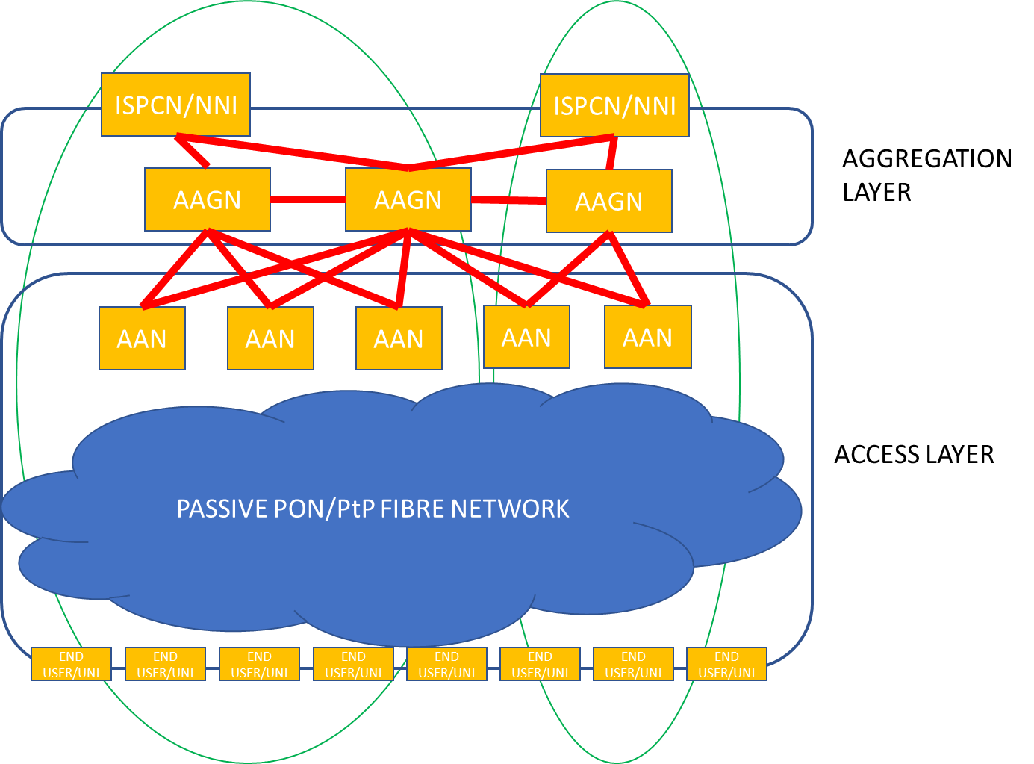

ACCESS NETWORK SCHEME

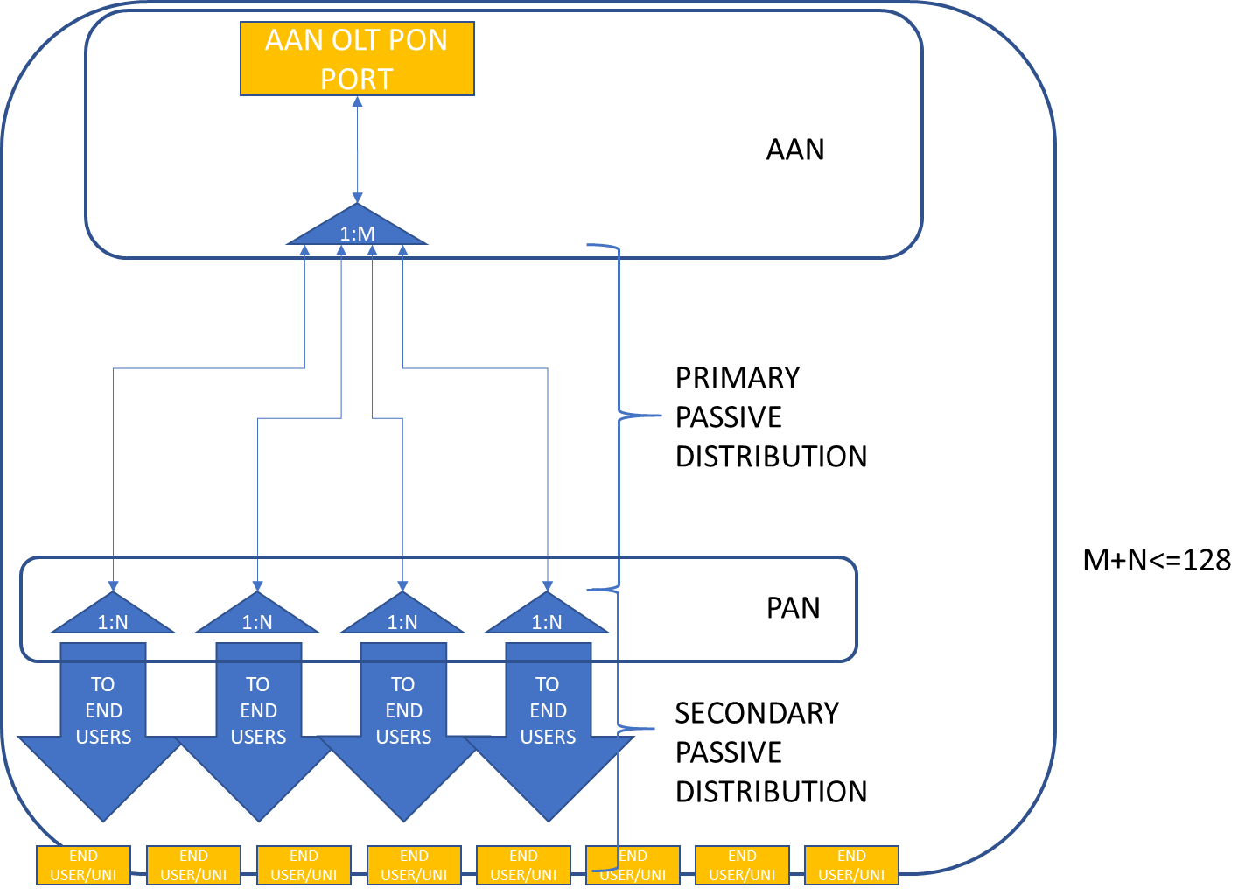

MATERIALS

Cables
All used fibre must be ITU-T G.657A1 or ITU-T G.657A2. Beside the types, specified in the 3.4.2. chapter, other fibre count cables may be necessary.

Pipes
A single type of PEHD pipe will be used in the project. 16mm outer diameter, 12mm inner diameter, 2mm wall is requested. Pipe must be tested to support the air pressures necessary to blow the mini cables. Colour is not important, but the % of recycled material in the plastic must be declared and previously agreed. Basic UV resistance is requested.
In case of use of existing underground infrastructure, pipes according to the infrastructure owner will have to be used.

Manholes/manhole closures
All manholes must respect all legal requirements for materials to be built in public roads.
Minimum size is 80cm diameter (if round) of 80x60cm (if square), with closure strength, adequate to the area, where it is mounted. Closure size must be 60x60cm (or 60cm diameter) or bigger.
The bidders for building works can offer to build (cast or mount) manholes on the field.

Cable supports for aerial cable deployment
Descriptions in chapter 3.4.2, materials not mandatory, but 25 years of life expectancy must be stated.

Cabinets
RUNE is willing to accept offers for metallic and plastic cabinets, to be mounted both on the ground and on the poles. All materials must be UV resistant, and have an expected lifetime of at list 25 years. The cabinets will be exposed to the natural elements. Cabinets should be closed with a lock with a unique key.
There are two types of cabinets, one to contain ODF and splitters on the field, and the other to contain only splice cassettes (aerial cable splice enclosure).
After the assignment of the BIC code, RUNE will share the non-binding ideas that we have developed about the cabinets, based on our past experience.
Bidders are invited to participate with their ideas and experiences and propose alternate products and solutions aimed to protect cable splice cassettes and fibre splitters.
What RUNE needs is not really a cabinet, but an adequate small container to protect the more vulnerable joints of the optical cable in the secondary access network, that will allow for as smooth future maintenance operation as possible.

